GPA CIE 2
Neeti Kurulkar
BE A Roll No: 31040

Q.1.
#include <stdio.h>
#include <cuda_runtime.h>

// Macro for error checking
#define cudaCheckError(ans) { gpuAssert((ans), __FILE__, __LINE__); }
inline void gpuAssert(cudaError_t code, const char *file, int line, bool abort=true)
{
if (code != cudaSuccess)
{
fprintf(stderr,"GPUassert: %s %s %d\n", cudaGetErrorString(code), file, line);
if (abort) exit(code);
}
}

// Kernel: each thread adds one element
__global__ void vectorAdd(int *A, int *B, int *C, int N) {
int idx = blockDim.x * blockIdx.x + threadIdx.x;
if (idx < N) {
C[idx] = A[idx] + B[idx];
}
}

int main() {
int N = 10;
int size = N * sizeof(int);

int h_A[N], h_B[N], h_C[N];
for (int i = 0; i < N; i++) {
h_A[i] = i;
h_B[i] = i * 2;
}

int *d_A, *d_B, *d_C;
cudaCheckError(cudaMalloc((void**)&d_A, size));
cudaCheckError(cudaMalloc((void**)&d_B, size));
cudaCheckError(cudaMalloc((void**)&d_C, size));

cudaCheckError(cudaMemcpy(d_A, h_A, size, cudaMemcpyHostToDevice));
cudaCheckError(cudaMemcpy(d_B, h_B, size, cudaMemcpyHostToDevice));

int threadsPerBlock = 256;
int blocksPerGrid = (N + threadsPerBlock - 1) / threadsPerBlock;
vectorAdd<<<blocksPerGrid, threadsPerBlock>>>(d_A, d_B, d_C, N);

cudaCheckError(cudaGetLastError()); // check launch
cudaCheckError(cudaDeviceSynchronize()); // check runtime

cudaCheckError(cudaMemcpy(h_C, d_C, size, cudaMemcpyDeviceToHost));

printf("Result:\n");
for (int i = 0; i < N; i++) {
printf("%d + %d = %d\n", h_A[i], h_B[i], h_C[i]);
}

cudaFree(d_A); cudaFree(d_B); cudaFree(d_C);
return 0;
}

Output:
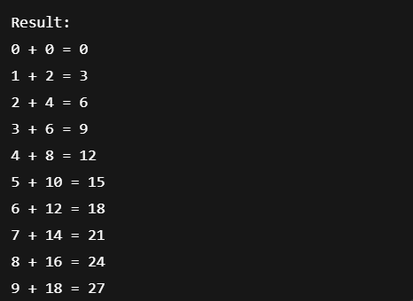

Q.2.
#include <stdio.h>
#include <CL/cl.h>

const char *kernelSource =
"__kernel void printNameDay() { \n"
" int id = get_global_id(0); \n"
" printf(\"Global ID %d: Neeti - Tuesday\\n\", id); \n"
"} \n";

int main() {
cl_platform_id platform;
cl_device_id device;
cl_context context;
cl_command_queue queue;
cl_program program;
cl_kernel kernel;

// 1. Get platform and device
clGetPlatformIDs(1, &platform, NULL);
clGetDeviceIDs(platform, CL_DEVICE_TYPE_ALL, 1, &device, NULL);

// 2. Create context and command queue
context = clCreateContext(0, 1, &device, NULL, NULL, NULL);
queue = clCreateCommandQueue(context, device, 0, NULL);

// 3. Build program
program = clCreateProgramWithSource(context, 1, &kernelSource, NULL, NULL);
clBuildProgram(program, 0, NULL, NULL, NULL, NULL);

// 4. Create kernel
kernel = clCreateKernel(program, "printNameDay", NULL);

// 5. Run kernel (5 work-items)
size_t globalSize = 5;
clEnqueueNDRangeKernel(queue, kernel, 1, NULL, &globalSize, NULL, 0, NULL, NULL);
clFinish(queue);

// 6. Cleanup
clReleaseKernel(kernel);
clReleaseProgram(program);
clReleaseCommandQueue(queue);
clReleaseContext(context);

return 0;
}

Output:
